С.Ю. Бацюкова
«Motivation Factors for Advocacy: Ukraine, Belarus, Lithuania»
мотиваційні фактори для адвокації: Україна, Білорусь, Литва

Analysis of sources
As a conceptual term “advocacy” is vague, complex, and perhaps even resistant to any sort of analysis and framing. The emerging need to evaluate the effectiveness of civic movements, to develop patterns regarding their implementation, to distinguish between advocacy and civic activism, advocacy and lobbying etc., makes advocacy a subject worth studying in Political Science and encourages academic research on the topic. Advocacy became a subject for research in political science around the 1980s. At different times, different authors divided advocacy into “active” and “passive,” depending on whether advocacy agents promote the interests/defend the rights of others or their own (Jenkins-Smith, 1995); into “internal” and “external,” depending on whether advocacy agents belong to the same or different spheres – for example the social and media spheres (Wade, 2011); into issue-based and systemic advocacy, where the latter is fueled by the former and derives its name from the systemic and complex advocacy actions (Dalrymple and Boylan, 2014); and into legislative and administrative advocacy (Schneider and Lester, 2001) based on the tactics employed.
The effectiveness of advocacy as well as other types of civic activism cannot be evaluated if the motivating factors are not known, not explored, or not taken into account. According to Gordon (2009), advocacy’s impact as well as motivating factors for advocacy differ depending on the level of its implementation: on international, regional, national, local, community, family, and inter-personal levels. As advocacy drivers Gordon takes into account the mission and goals of organization, the interests and problems of the community, and the anticipation of and motivation for change. Zimmerman (2000) identified behavioral changes in society, for example those that seek to exert control, as a motivation for advocacy.
Ricketts and Aidan (2013) hold that advocacy is motivated by interests. It may be based on individual/private, collective, or vested interests. As follows from Ricketts and Aidan’s analysis, any advocacy campaign may start as a self-driven action and then gain support of a community or society, turning into a massive collective action promoting public interest at the large-scale level. In the “Activists’ Handbook,” they also describe the intersection between vested and public interests as advocacy drivers; vested interests may become public interests under certain circumstances – e.g. campaigns by trade unions for better conditions may have important benefits for a certain industry (vested interest), but these are also public interest campaigns “because of their role in achieving and maintaining these standards for workers generally.” (Ricketts and Aidan, 2013: p.30)
A lack of analysis emerges if we look at the advocacy drivers in connection with specific freedom statuses of countries. Considering the aforementioned specific advocacy-related analysis, the main purpose of the article is to demonstrate how motivating factors for advocacy depend on the country’s freedom status as it is defined in the Freedom in the World Report. Ukraine, Belarus and Lithuania were used as the basis for analysis given their contrasting Freedom statuses: a non-free authoritarian regime in Belarus, a partly-free transitional regime in Ukraine, and free consolidated democracy in Lithuania.
It is the hypothesis of this research that the value of advocacy factors may vary in free, partly free, and non-free countries. The Freedom in the World Report annually assigns numerical ratings in two categories, civil liberties (CL) and political freedoms (PF), which then determine if the country has an overall status of free, partly free, or not free. The numerical ratings are assigned on a scale from 1 to 7 where 1 is most free and 7 is least free. According to the 2016 report, Belarus was rated not free (PF=7; CL=6; Freedom Rating=6.5), Ukraine was rated partly free (PF=3; CL=3; Freedom Rating=3), and Lithuania – free (PF=1; CL=1; Freedom Status = 1).

Methodology

The article analyzes survey data. The survey was conducted by the author in 2014-2016. It was a part of a pilot study and was conducted among 147 Ukrainian, Belorussian and Lithuanian activists who were selected to take part in international training courses under auspices of the Ukrainian and Belorussian Human Rights Houses and were engaged in different advocacy activities in Belarus, Lithuania and Ukraine. Activists were chosen to take part in international training courses based on similar selection criteria: knowledge, experience, motivation, and level of civic activism. Selected participants were: journalists working for local, regional, and national media; human rights defenders; staff of legal clinics; activists of youth and student organizations; staff of NGOs providing legal and humanitarian assistance, etc. Preference was given to those who had not taken part in similar schools/events before, but have strong practical experience in human rights protection, delivery of legal and humanitarian assistance, and/or provision of services to underserved groups. One-hundred and forty seven civic activists from Ukraine (62), Belarus (43) and Lithuania (42) took part in the survey.
Given the fact that respondents had a strong knowledge of advocacy and its role in society, and of the level of execution of rights and freedoms in society, results of the survey may be extrapolated to the level of civil society as a whole in the target countries.
The survey consisted of three questions. The English translation of the survey questions is provided below.
- What are advocacy drivers? (please choose)
- Individual interest/ problem
- Public interest/ problem
- Can advocacy be implemented in non-free regimes? (please choose)
- Yes
- No
- How likely, in your opinion, are these factors to become drivers for advocacy in society?
(please assign a ranking from 0 to 5, where 5 is the highest)
- Pressure from the international community/organizations
- Dissatisfaction with the actions of those in power
- Violation of rights and freedoms
- Absence of laws/norms and/or their non-implementation
- Feeling of injustice
- Promotion of an idea/interest
In questions 1 to 4, respondents could select one of two options or could choose both. Responses to questions 1 to 4 were assigned a value of 1 percent. Respondents provided answers to all questions (there were no incomplete questionnaires). In question 5 participants were asked to assign a value to each provided factor. Given the different frequencies of these values, weighted means were calculated to derive the weight of each factor.
Analysis

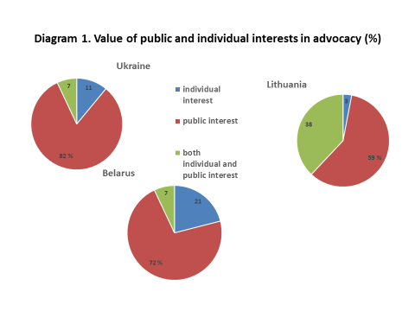

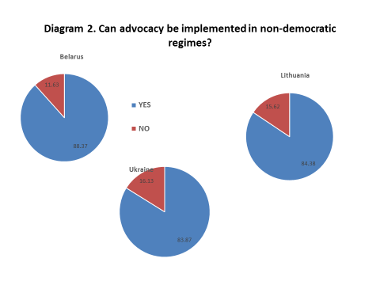

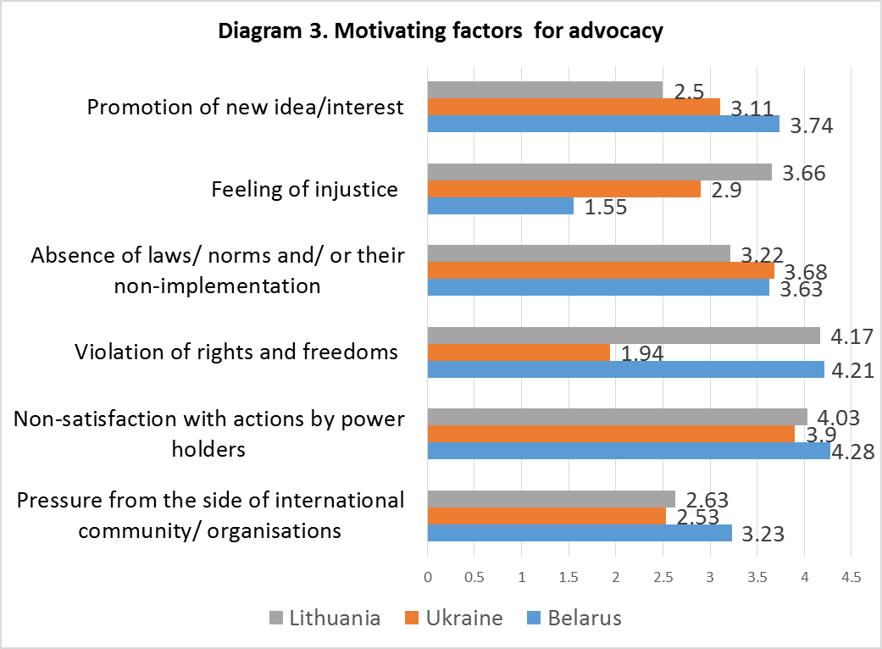
Results and conclusions
The article explores the issue of whether and how much significance of advocacy motivating factors vary in countries with different freedom statuses (based on the 2016 Freedom in the World Report). Three post-Soviet countries – Ukraine, Belarus and Lithuania – were chosen as target countries for the analysis. These countries have different freedom statuses: Lithuania is “free’, Ukraine is “partly free”, Belarus is “non-free.” Regardless of the status of implementation of political freedoms and civil liberties, all countries are known for implementing sound advocacy campaigns. The vast literature explored for the purposes of the article showed different factors that drive advocacy but not to what degree these factors impact and motivate advocacy under conditions where freedom is limited, partially limited or fully realized.
The survey conducted by the author of the article reveals that Belorussian, Lithuanian and Ukrainian respondents viewed individual interest as a less probable motivating factor for advocacy compared to public interest. This may refer to the fact that public interest is often connected with public activity and individual interest – with activity that is purely of a personal nature. Thus, advocacy as a type of public activity is more often connected with public interest than with individual interest.
As stated in over 80 percent of responses, non-free authoritarian regimes are not seen as an obstacle for advocacy implementation.
The cumulative analysis of responses demonstrated that dissatisfaction with actions by power-holders appears as the most important driver for advocacy in Belarus, Ukraine and Lithuania. At the same time, absence of legal norms and/or their poor implementation or non-implementation and the need to promote/protect ideas, as well as perception of injustice in society were described as significant factors for initiation of advocacy actions. Pressure from the international community (e.g. presentation of shadow reports, implementation of sanctions etc.) was defined as the least important factor in promoting advocacy in both countries. Respondent data showed that violation of rights and freedoms is a far more important advocacy motivator for Belarus and Lithuania than it is for Ukraine. Based on survey results, it is twice as likely that violations of rights and freedoms would lead people to protest in Belarus and Lithuania than in Ukraine. The feeling of injustice plays greater role in motivating advocacy in Ukraine and Lithuania than in Belarus. It is twice as likely that perception of injustice in society would drive advocacy in Ukraine compared to Belarus.
Promotion of new ideas/interests serves an important factor for advocacy in both Ukraine and Belarus (values of 3.74 in Belarus and 3.11 in Ukraine) in opposite to Lithuania.
By analyzing participants’ responses from Belarus, Ukraine and Lithuania, the author did not observe differences in responses about the environment where advocacy may be implemented and flourish. Neither Belorussian nor Ukrainian, nor Lithuanian respondents saw the “non-free status” of a country as an obstacle to advocacy implementation.
The author’s analysis found evidence of a relationship between advocacy drivers and country freedom statuses (levels of political freedoms and civil liberties in the country). Specifically, the analysis holds that the same motivating factors may outperform or underperform in countries with different freedom statuses. Thus, the author suggests that significance of advocacy drivers varies depending on a country’s freedom status.
Bibliography
- Dalrymple, J., Boylan, J. 2013. Effective Advocacy in Social Work. Sage Publication Ltd.
- Freedom House. Freedom in the World 2016 [online] Available at https://freedomhouse.org/sites/default/files/FH_FITW_Report_2016.pdf [Accessed April 4, 2016].
- Gen, S., Wright, A., 2013. Policy advocacy organisations: A framework linking theory and practice. Journal of Policy Practice, 12 (3), 163-193.
- Jenkins- Smith, Hank, 1999. The Advocacy Coalition Framework: an Assessment. Theories of the Policy Process, ed.Sabatier P., 117-68. Boulder, CO: Westview Press.
- Lester, L., Schneider, R.L, 2001. Social Work Advocacy: A New Framework for Action. Brooks/ Cole.
- Ricketts, Aidan, 2012. The Activists’ Handbook: A step-by step guide to participatory democracy: Zed Books Ltd.
- Wade, L., 2011. Journalism, advocacy and the social construction of consensus. Media, Culture and Society, 33 (8), 1166-1184
- Zimerman, 2000. Self-Efficacy: An Essential Motive to Learn. Contemporary Educational Psychology (25), 82–91
- Бацюкова C., 2014. Визначення адвокації як предмету дослідження в політології. Вісник ХНУ імені В. Н. Каразіна, № 1132, серія „Питання політології”, 77-82.
- Гордон Г., 2007. Пособие по адвокации: Что такое адвокация? Tearfund. Available from https://www.helsinki.org.ua/chto-takoe-advokatsiya. [January 10, 2016]

